Project Development Phase
Model Performance Test

Date | 10 February 2025
Team ID | SWTID-2026-6670
Project Name | Implement Client Script & UI Policy (Incident)
Maximum Marks

Model Performance Testing:
Project team shall fill the following information in model performance testing template.
S.No. | Parameter | Screenshot / Values
 | Data Rendered | Incident records are rendered in the ServiceNow Incident list (Incident > Open / All) and on the Incident form. The Active list shows 41 records.  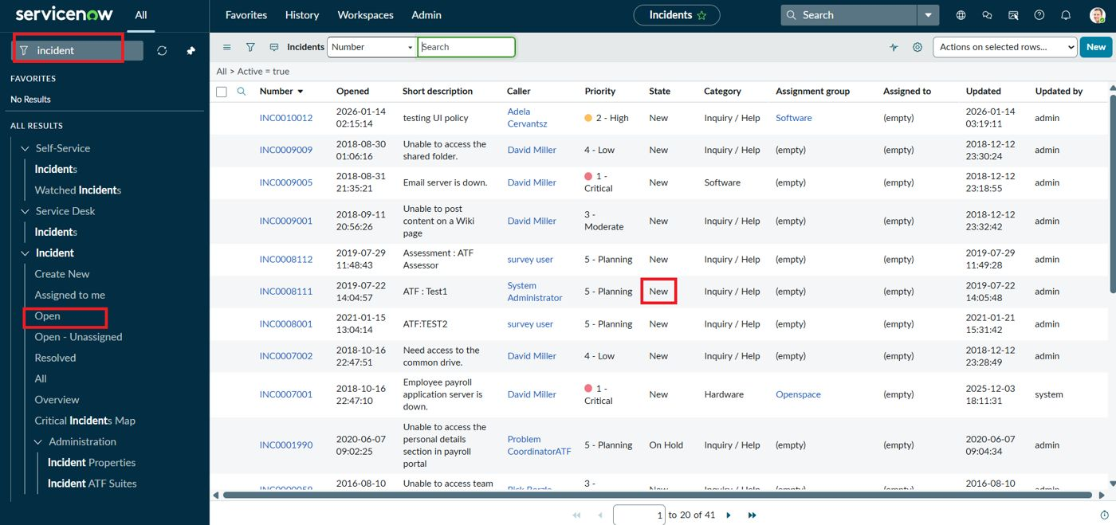
 | Data Preprocessing | No separate preprocessing is required. The data is native to the Incident table; data quality is enforced at entry by the UI Policy and Client Scripts (mandatory Assignment group, auto-set Urgency, Assigned To check).
3. | Utilization of Data Filters | UI Policy condition: Impact is 1 - High (Reverse if false enabled).  List filter: Active = true.  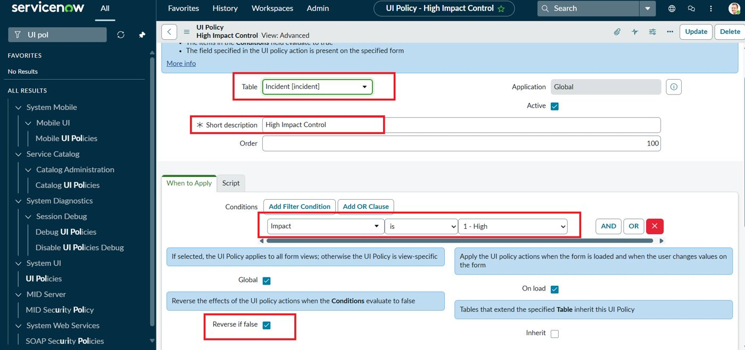
4. | DAX Queries Used | Not applicable (Power BI / DAX not used). Equivalent logic is client-side JavaScript: onSubmit blocks the save when impact == '1' and assigned_to is empty; onChange sets urgency to '1' when impact is '1'.  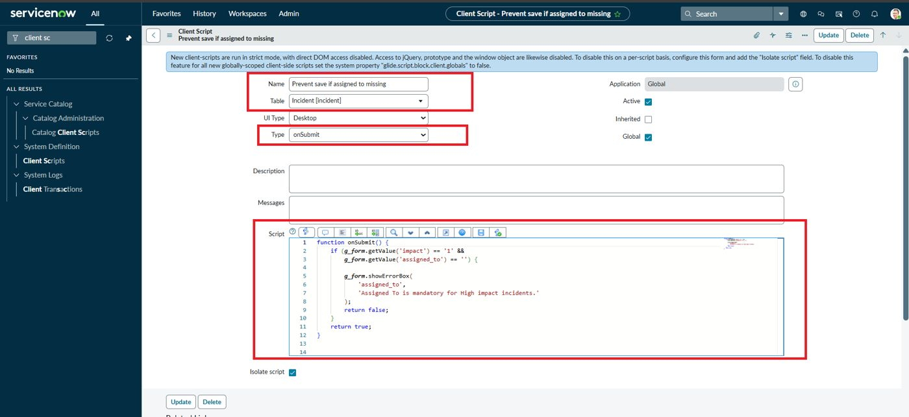
5. | Dashboard design | No of Visualizations / Graphs - 0 (no custom dashboard built; the Home page shows the default ServiceNow admin dashboard)  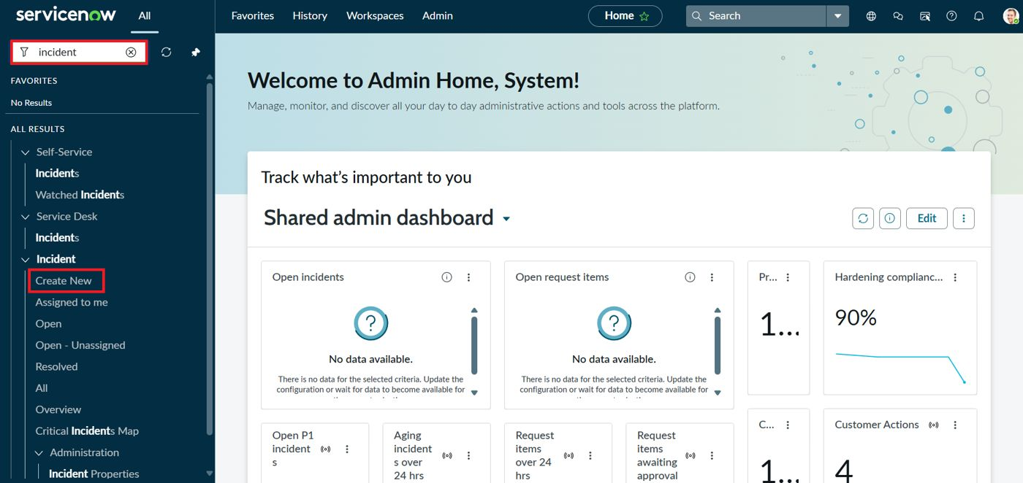
6 | Report Design | No of Visualizations / Graphs - 0 (no custom report built; the Incident list view is used to review results)

